Practical exam requirements

* Journal
* Topic, algorithm, program, output(handwritten)

7/9/21

Heap and binary tree

Max heap , min heap

Max heap = parent node >= child node

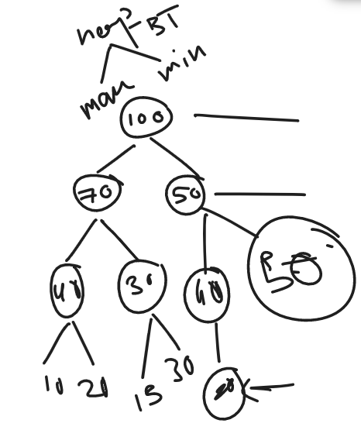

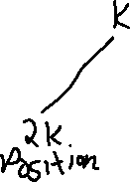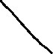

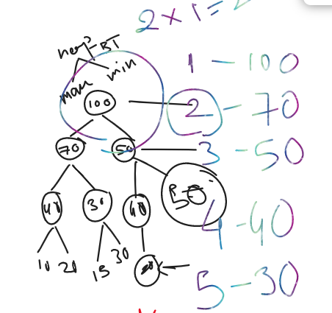

100, 70, 50, 40, 30, 40, 50, 10, 20, 15, 30, 20

With position

1, 2, 3, 4, 5, 6, 7, 8, 9, 10, 11, 12 respectively

If the condition i.e. parent should be greater than child is not satisfied then swapping should be performed.

If child’s position is 5 then parent’s position is 5/2 = 2

4 then 4/2 = 2

7 then 7/2 = 3

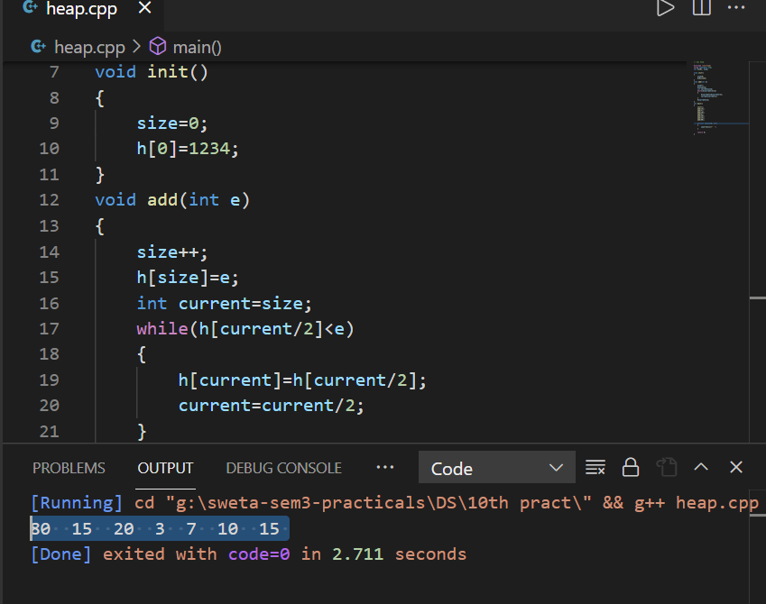max heap

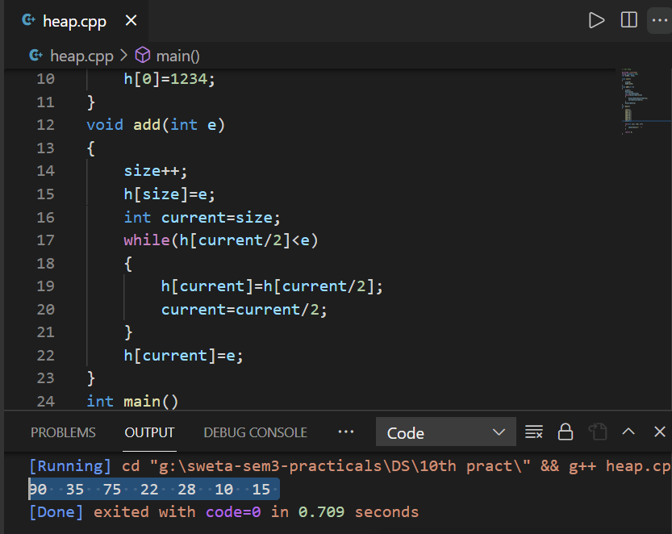

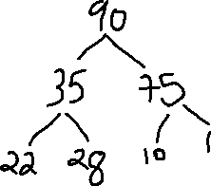

// max heap

#include <iostream>

using namespace std;

int h[20], size;

void init()

{

    size=0;

    h[0]=1234;

}

void add(int e)

{

    size++;

    h[size]=e;

    int current=size;

    while(h[current/2]<e)

    {

        h[current]=h[current/2];

        current=current/2;

    }

    h[current]=e;

}

int main()

{

    init();

    add(75);

    add(22);

    add(10);

    add(35);

    add(28);

    add(15);

    add(90);

    for(int i=1; i<=8; i++)

    {

        cout<<h[i]<<"  ";

    }

    return 0;

}

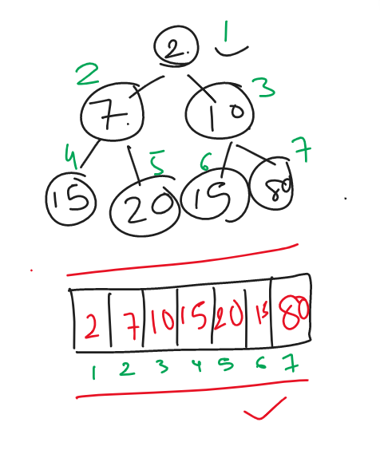

Min heap